Children will be introduced to their spellings on Mondays and then will be tested on them on Thursdays. We will also practise them in school during the week.
Name: Year 5 Spellings Spring 2
The words in blue are additional challenge words (these are optional).
Spelling focus | Homophones or near homophones | Homophones or near homophones | Challenge words | Revision of previous spellings | Revision of previous spellings
Test date | 2.3.23 | 9.3.23 | 16.3.23 | 23.3.23 | 30.3.23
 | Cereal  Serial  Complement  Compliment  Stationary  Stationery  Wary  Weary  Principal  Principle  Aggressive  Community | Affect  Effect  Precede  Proceed  Draft  Draught  Dessert  Desert  Whose  Who’s  Determined  Especially | Reliably  Accommodate  Changeable  Afterwards  Referring  Knight  Doubt  Amateur  Ancient  Deceive  Exaggerate  Familiar | Receive  Neither  Elegance  Gracious  Malicious  Nutritious  Fictitious  Infectious  Social  Essential  Immediately  Neighbour | Knight  Pterodactyl  Island  Autumn  Practice  Practise  Farther  Father  Guessed  Guest  Disastrous  Sincerely
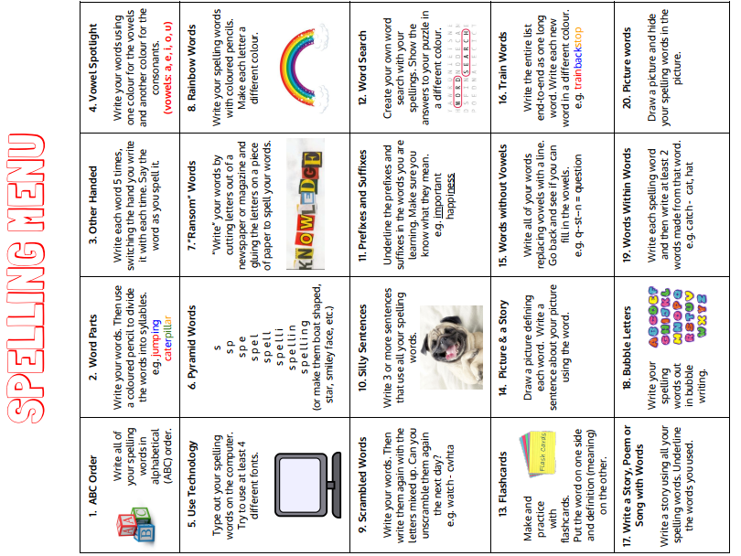
Please turn over to view the ‘Spelling menu’ which gives suggestions for fun ways to learn spellings!

