Live Lessons | FOR YOUR INFORMATION W/B 1st March 2021  On Wednesdays and Fridays I will be at school. I will endeavour to answer your questions and feedback on children’s learning but there may be a short delay.  On Mondays, Tuesdays and Thursdays there will be a learning support session at 11:30am live on Microsoft Teams (questions should be sent to me on Seesaw before 11:00am)  LIVE STORYTIME (Will also record these sessions for you to access at a time that suits you and your family)  These sessions will take place on a Monday, Tuesday and Thursday at 1:00pm on Microsoft Teams live.  Wellbeing group sessions (approx. 15 mins long by appointment)  Children will receive an invitation to a group chat on Microsoft Teams so that they can keep in touch with their peers and class teacher during the lockdown period. These sessions should appear on your Teams newsfeed.  Monday  - Group A 10:00am  - Group B 10:30am  Tuesday  - Group C 10:00am
 | Monday | Tuesday | Wednesday | Thursday | Friday
Reading | Each day, please spend some time on reading eggs.  At the beginning of the week I will set an assignment, once this is completed you should continue to work your way through the ‘Reading Eggspress’ map.  Continue to read at home and get your reading record signed

Writing | Choose a creative activity from page 25 or 26 to complete today. | Dragonworld (pobble365.com)  Complete the ‘Question Time’ and ‘Perfect Picture’ activities. |  |  | Dragonworld (pobble365.com)  Complete the ‘Sentence Challenge’ and ‘Sick Sentences’ activities. | Dragonworld (pobble365.com)  Write the next paragraph/s of the story starter. |  |  | I hope you have enjoyed the different activities this week to celebrate World Book Day. Today, I would like you to tell me all about your favourite book!  Write a book review about your favourite book, there are some tamplates in the resource folder to help you.
SPAG | Choose an activity from the spelling menu to help you to learn this weeks spellings.  Keep an eye out for different spelling assignments set on Reading Eggs as well!  Remember you can practise spellings on Reading Eggs at any point by clicking on the ‘English Skills’ section. |  |  |  |  |  |  | Complete your spelling test with someone in your home  You can share your results with me via seesaw
Maths | What is Area?  Watch the video and complete the worksheet in the resources folder.  Spring Week 4 - Measurement: Area | White Rose Maths |  | Counting Squares  Watch the video and complete the worksheet in the resources folder.  Spring Week 4 - Measurement: Area | White Rose Maths | Making Shapes  Watch the video and complete the worksheet in the resources folder.  Spring Week 4 - Measurement: Area | White Rose Maths |  | Comparing Area  Watch the video and complete the worksheet in the resources folder.  Spring Week 4 - Measurement: Area | White Rose Maths | Area and Perimeter Challenge  Area and Perimeter (maths.org)
Topics | This week we will be celebrating World Book Day. Each day, choose one of the activities from the grid below.

Finish the story...  Write the next chapter/pages of your favourite book. Think carefully about what could happen next. | The Masked Reader  Video Link at the bottom of this document. | Celebrate World Book Day with Mrs Marples by creating your very own ‘book nook’!  Link to video at the bottom of this document.
Guess the character quiz with Mrs Mayho  Quiz link at the bottom of this document. | This week we are focusing on the Wonderful World of Books!  Each day, choose an activity and be sure to continue reading your favourite books! | Recreate your favourite part of a book.  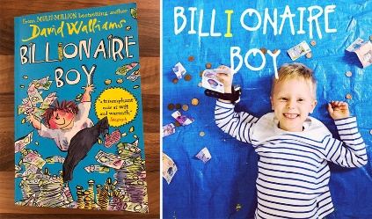  Take a picture or video of you acting out your favourite part of your favourite book. You may wish tod ress up, add props or get your family involved!
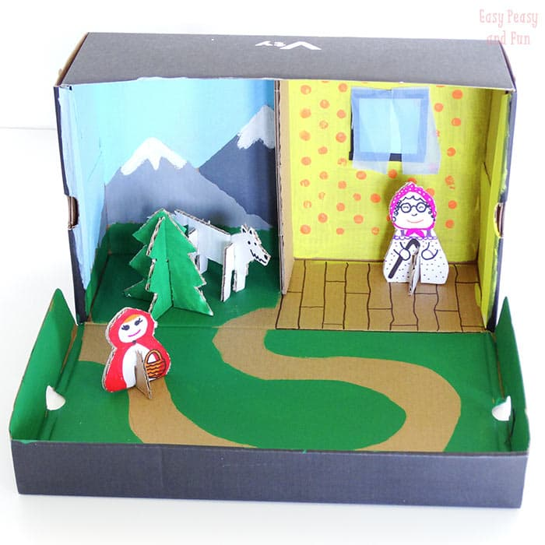  Creative Task 1:  Create a setting from a story in an old shoe box. | 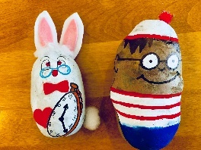  Creative Task 2:  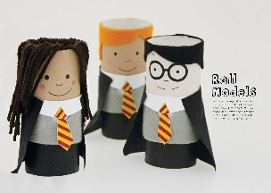  Re-create your favourite character as a potato character or using a toilet roll tube! | Creative Task 3:  Create a book mark to help mark the page in your favourite book.  I will include some templates for this in the resources folder including templates for the animal corner markers, or you can create your own.

Mrs Mayho’s Character Quiz
https://www.loom.com/share/d7daae46b8cd473fab4a2301889ae8be

Mrs Marples Outdoor Challenge
Book Nook - YouTube

Mrs Mayho’s Masked Reader
https://www.loom.com/share/8039c03e5b3e442ab5ee27b73e514e60

